Physical Recreation Activity Badge
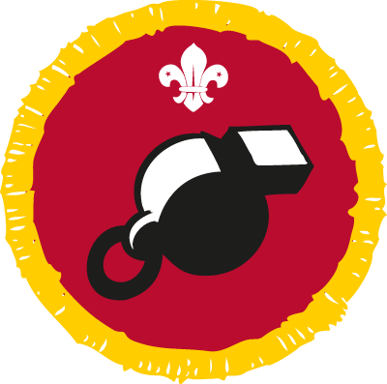
How to earn your badge
- Show a good sporting attitude in all games and sports you take part in.
- Tell your leader about the sports you take part in. Find out as much as you can about your sports, especially the rules.
- Show that you’re fairly skilled in your sports. Take part for three months or more in at least one of your chosen sports.
- Bring the clothing and equipment for the sport you’ve chosen along to a meeting. Show how to look after them.
- Tell a leader about the training and preparation you take part in for your chosen sport. How and when do you practise?

I confirm that................................................................has met the above stated requirements 1 and 3 for the Physical Recreation Badge.

Signed..........................................................................

Date ......./......../...........

Please bring this form to a meeting along with the everything you need to complete requirements 2, 4 & 5.

Leaders Signature………………………………………………………………..

